LEGO MINDSTORM

Following a line edge

# Beginner Level – Zigzag following

## Robot Setup

You can use almost any robot with turning capabilities.

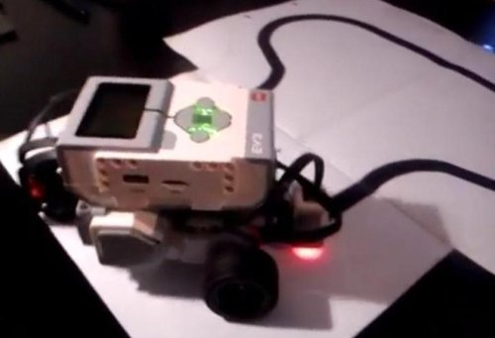

Set your colour sensor on the front of your robot.

Tip: Covering around the sensor so no light comes in will help get more accurate readings.

## Program Setup

### Blocks needed

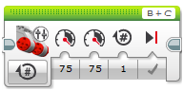 Move Tank

Check Motor Letters

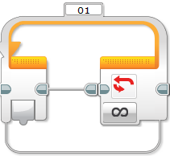 Loop

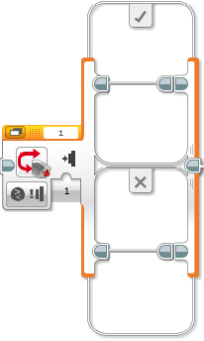 Switch

### Program

#### Step 1 - Switch

Change your switch to compare Reflected Light Intensity

#### Step 2 – Light Value

Once the light reflected is greater than 40 (between 20 – 40 test your own value) you’ll want to turn left or right to find the black line again.

Find your own values

Check Sensor Number

#### Step 3 – Turning Motor

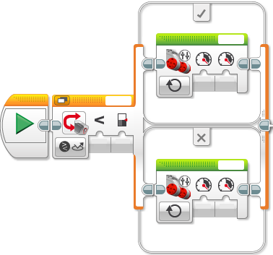

Find your own values

#### Put a Move Tank in each part of the switch.

Check Motor Letters

Test your values to turn left or right.

Tip: One will be less than the other and don’t make it too fast or your robot won’t find the line.

#### Step 4 – Loop

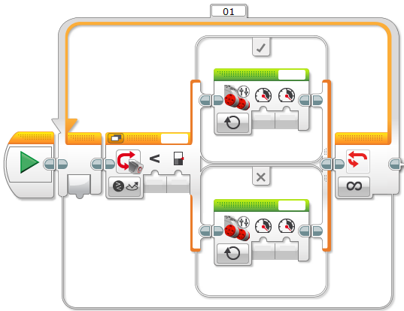You’ll want your robot to keep going, so you’ll need a loop.

This will go forever, however you’ll want it to stop.

Here are some suggestions for how to stop:

* Time – after 5 sec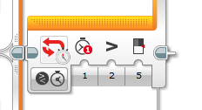
* Distance – after 5 rotations

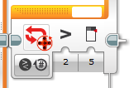

Check Motor Letter

## Answer

